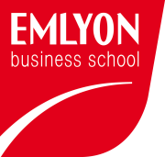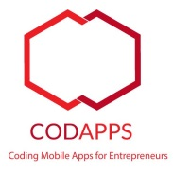Apple delivers two types of certificates for iOS apps: Development certificates, and Distribution certificates.

**[www.codapps.io](http://www.codapps.io)** by Clement Levallois **@codapps_io** [**www.coursera.org/learn/codapps**](http://www.coursera.org/learn/codapps)



**Module 4: Testing your app on a phone and distributing it**

*Testing your app on an iPhone: 2 options.*

* Development certificates allow you just to install your app on a phone you own.
* Distribution Certificates enable your app to be distributed on the app store.

You have a choice between 2 options:

OPTION A:

You take a regular Apple Developer account, that allows you to create Development and Distribution Certificates, quite easily, and you can then test your app on your phone and distribute it on the app store. You pay 99$ to Apple for this.

OPTION B:

EMLYON has negotiated a partnership with Apple to give you free Development Certificates. The good news is, you save the 99$ that everybody usually has to pay to develop apps for Apple!

The bad news is that the process to create these certificates is much longer that option A. Easy, but that takes a lot of steps. And you get a Development Certificate, not a Distribution Certificate, so your app will not be distributed on the App Store – just on your phone ☹.  
**Note: if you take this option, the name of the package of your app should start with io.codapps.**

You are free to choose any option.

Please read the pdfs which mention option A and B in their name, depending on what you choose.